E537 Support Tool v2.0
Support Tool Design

Author: | Ashutosh Das
Approver: | Baskaran P.
File: | Support Tool-Design- Draft 0.1
Status: | Draft
Issue: | 0.1
Date: | 04 Oct 2016
Contents
1 Introduction 3
2 Support Toolset Structure 4
2.1. Functional Structure 4
2.2. SUPPORT TOOL Database Schema 4
3 Support Tool 5
3.1. Use Case Model 5
3.2. Use Case Descriptions 6
3.2.1. Login 6
3.2.2. Create new User 6
3.2.3. Search 7
3.2.4. View Status 7
3.2.5. View Payload 8
3.2.6. Work List 9
3.2.7. Search - Sequence Diagram 10
3.2.8. Multiple Database Site Accessibility 11
4 Document control information 12
4.1. Configuration management 12
4.2. Reviewers 12

Introduction

The Support Tool is required primarily by the support group(PEM Team) and the Support Tool design and development team in Computing Partners.
At the time of writing the Support tool consists of the following:
- Support Tool – allows the user to interrogate the status of an order to a supplier. The user is allowed to enter search criteria, which should be displayed alongside the relevant information on the status of the workflows involved in a B2B conversation with a supplier.

- Work list Tool – allows the bulk resubmission of Messages(jobs). This tool enables a user to action jobs which have dropped out on to a manual queue. This can happen if a supplier doesn’t respond correctly (through the use of a delivery receipt) within a specified period of time, or if NIMS throws a non- retrievable error message. The user enters the standard login details to access the Work list tool and from then on they can resubmit or remove jobs, based on their role. This tool is to be used in conjunction with the support tool to allow the user to make a decision on what should and should not be re-sent.

Support Toolset Structure

Functional Structure
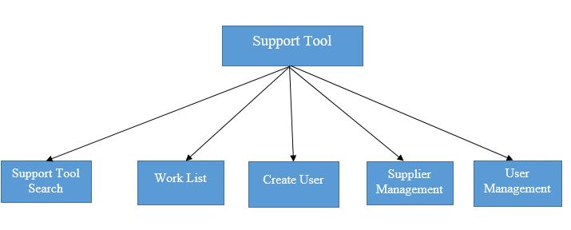

SUPPORT TOOL Database Schema
The database is comprised of five tables:
- ORSS_MESSAGE_DETAILS
- ORSS_RECEIPT_CORRELATION
- ORSS_MESSAGE_CODE
- ORSS_SUPPLIERID
- ORSS_SUPPORT_TOOL_USERS
- ORSS_PROPERTY
- AUDIT_LOGS

Table ORSS_SUPPORT_TOOL_USERS used for user creation and maintenance, Table ORSS_MESSAGE_DETAILS and ORSS_RECEIPT_CORRELATION used for Support Tool search and work list. ORSS_MESSAGE_CODE and ORSS_ SUPPLIER_ID static tables used for to display search list values in the screen. ORSS_PROPERTY static table is used for storing and retrieving various properties and AUDIT_LOGS table is used for user activity tracking.

Support Tool

Use Case Model

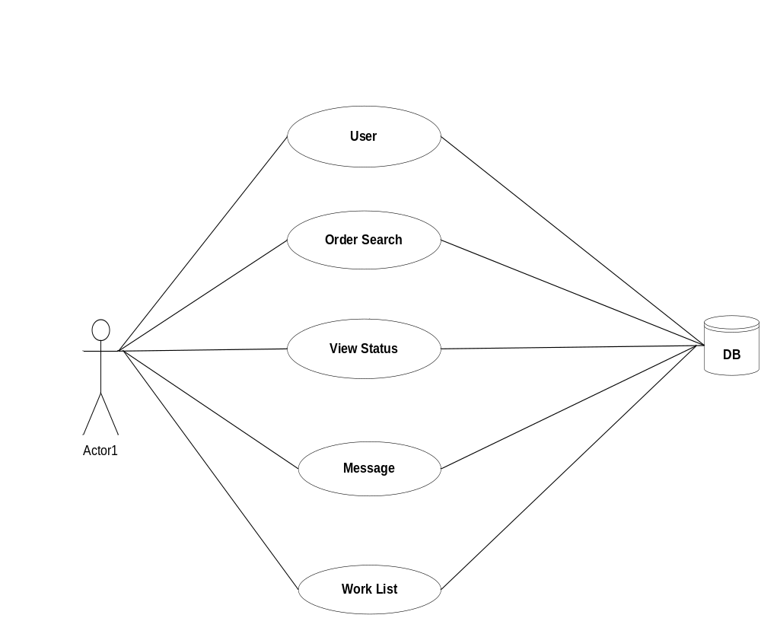

Use Case Descriptions

Login

Brief Description
This use case describes how a user logs in to the system.

Flow of events
This use case begins when the user decides navigate to the Support Tool.
1. The user enters the tool’s URI into a browser and is prompted to enter their username and password.
2. The user submits the information.
3. System validates the user credentials and gives access to the tool.

Alternative Flow of Events
If the user enters invalid user credentials they are prompted to retry.

Pre-conditions
None

Post-conditions
If the use case was successful, the user is logged on to the system. If not, the system state is unchanged.

Create new User

Brief Description
This use case describes how an admin user creates a new user in to the system.

Flow of events
This use case begins when the admin user decides to create a new user to access the Support Tool.
1. The admin user clicks create new user and is prompted to new user account and it allows new user name, password, confirm password and role has two option one super user and normal user.
2. The user submits the user information.
3. System validates the user credentials and creates a new user based on input and show information user successfully created.

Alternative Flow of Events
If the admin user enters invalid user name, password and confirm password they are prompted to entre the new values. After that only the system will allow to create a new user until the system won’t be allowing new user creation.

Pre-conditions
None

Post-conditions
If the use case was successful, the system to allow to create user If not, the system is unchanged.

Search

Brief Description
This use case describes how a user runs a search from the Support Tool.

Flow of events
This use case begins when the user decides to run a search on the Support Tool.
- The user enters the relevant search criteria into the proper search fields and submits the search.
- The system validates the search criteria.
- The system runs the search and returns results.

Alternative Flow of Events
If the search returns results containing more than specified number of records, a message is displayed prompting the user of this fact and suggesting to download records as a csv file. At this point the user may choose to continue the search result downloading , refine the search or abort.

Pre-conditions
The user must be logged in to the system.

Post-conditions
If the use case was successful the results matching the search criteria will be returned or downloaded. Otherwise the system is unchanged.

View Status

Brief Description
This use case describes how a user views the status of a particular job.

Flow of events
This use case begins when the user decides to view the status of a single job within displayed results:

1. The user clicks the particular message row in the table.
2. The system searches for the status details of the relevant message and prompts the user with two options as status and payload.
3. By selecting status ,the system displays the job’s status details.

Alternative Flow of Events
None

Pre-conditions
The system has already returned results for a search.

Post-conditions
If the use case was successful, the status of the selected message will be displayed. If not the system state will be unchanged.

View Payload

Brief Description
This use case describes how a user may view the messages related to a particular job.

Flow of events
This use case begins when the user decides to view the message payload related to a single job within a displayed results:
1. The user clicks the required message from the table and prompted with two options as status and payload..
2. Now user can select payload option to see the message payload.

Alternative Flow of Events
None

Pre-conditions
The system has already returned results from a search.

Post-conditions
If the use case was successful, the message payload related to the job will be displayed. If not, the system state is unchanged.

Work List

Brief Description
This use case describes how a user to do work list operations.

Flow of events
This use case begins when the user decides to go work list click work list link option it displays work list page.

1. The user selects the job ‘Work list’ link.
2. The system display the work list screen based on user role of the relevant job. This link is only visible to user having role as admin or super user.
3. The system displays the work list tasks details.
4. If the user has Super user role system to allow Resubmit/Remove the messages which will be displaying the work list task screen.
5. Sytem to allow for the both user can change view and size of the messages.

Alternative Flow of Events
None

Pre-conditions
The system has already displayed for the work list tasks.

Post-conditions
If the use case was successful, the work list task of the relevant job will be processed. If not the system state will be unchanged.

Search - Sequence Diagram
The following diagram describes the normal course of events after submission of a search.
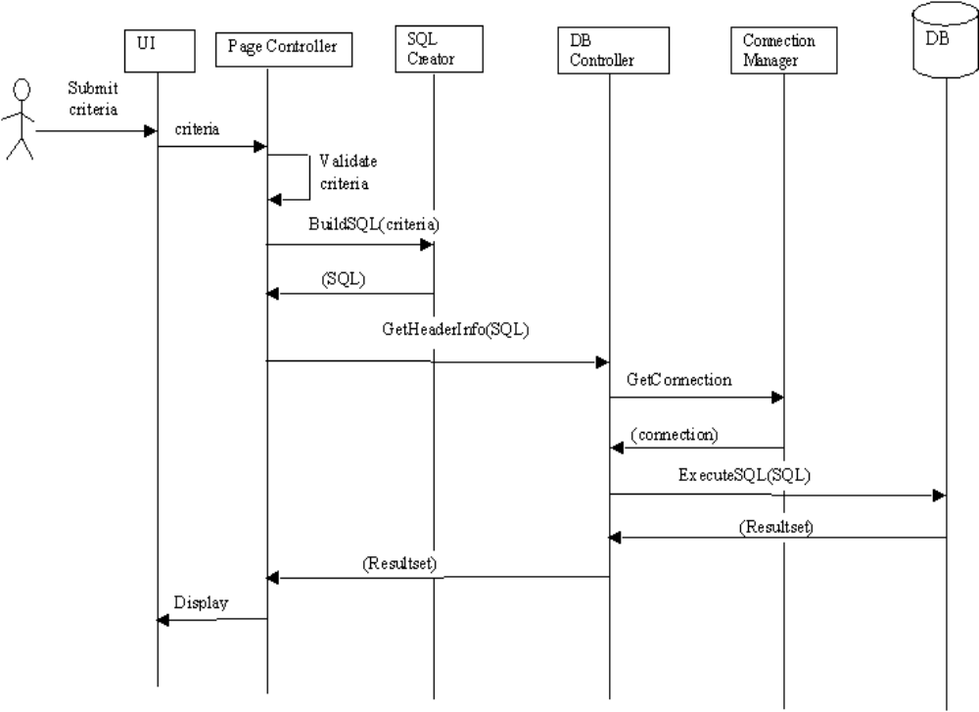

Multiple Database Site Accessibility

Brief Description
After successful authentication user should landed to the home page with a default database site selection. User should be able to change the site only from the home page. Currently user can select any one out of two database sites. The state of both the sites should be configurable and not hard coded or coupled with the system.

Flow of events
This use case begins when the user decides to change the database site.

1. The user clicks the dropdown selector on the home page.
2. The system display the available sites.
3. User now select the site by clicking select site button.

.

Alternative Flow of Events
None

Pre-conditions
The system has already displayed list of available sites.

Post-conditions
If the use case was successful, the selected site will be reflected for all subsequent visit . If not the system state will be unchanged and proper message will be displayed to the user.

Document control information

Configuration management
Owner:
Filename: | Support Tool-Design Draft 0.1.doc
Location of Master:
Medium:
Format: | Microsoft Office
Paper Archive:
Electronic Archive:
Copyright:

Reviewers
List of reviewers of the document (along with their titles/roles).

End of Document

